P.G.I. RECOGNITION FORM

CLUB NAME __________________________________________CLUB NO. ___________
MEMBER NAME MBR # LEVEL DATE
_____________________________________ _________ _______ ____________
_____________________________________ _________ _______ ____________
_____________________________________ _________ _______ ____________
_____________________________________ _________ _______ ____________
_____________________________________ _________ _______ ____________
_____________________________________ _________ _______ ____________
_____________________________________ _________ _______ ____________
_____________________________________ _________ _______ ____________
_____________________________________ _________ _______ ____________
_____________________________________ _________ _______ ____________
CERTIFIED BY:
____________________________________ ___________________________________
President’s Signature (Level 1- VII) OR Secretary-Treasurer’s Signature (Levels I – VII)
Governor’s Signature (Level VIII- X) OR Lt. Governor’s Signature (Levels VIII – IX)
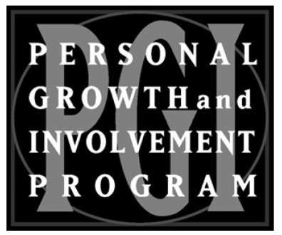
THIS FORM MUST BE SENT BY THE
CERTIFYING OFFICIAL TO:
Director of Personal Growth
Dorothy Irvin
507 Pettus Street
Selma, AL 35701-5740

