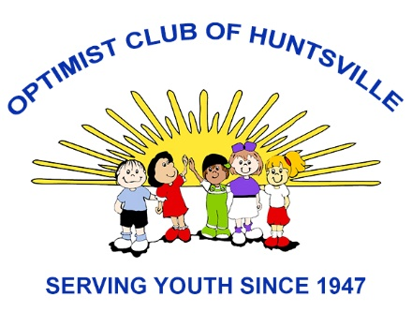
Member Interest Finder

Name:_________________________________________ Date: ____________________
We wish to have you active in our club. Please review the following and check the items that you might be interested in supporting.
____ Junior Optimist Octagon Clubs (JOOI) – Act as the club interface with the school advisor of a JOOI Club. We generally try to have at least two members assigned to each JOOI Club.
____ Band Instrument Loan Program – We own about 185 instruments that we loan to students that would not otherwise be able to take band. The club member delivers instruments from our storage room to the Band Director at the school. At the end of the year they collect the instruments and present an award to a student. No knowledge of musical instruments is needed.
____ Tri Star Basketball Contest – Check 3 skills of each kid, hand out lots of trophies. No basketball skills required. Lots of fun.
____ Essay contest – Distribute information to schools, collect essays.
____ Oratorical Contest - Distribute information to schools collect applications.
____ Youth Appreciation Week – Distribute information to schools and collect honoree's names. Present awards at banquet.
____ Publicity ____ Fellowship ____ Newsletter ____ Finance
____ 4H Judging ____ Fundraising ____ Membership ____ Programs
____ STEM Grants ____ Other ____________________________________________________
What is your experience in community betterment, church work, sports and youth serving activities that could help our club?

What projects or programs would you like the club to consider? (Use back of form if needed)

